**INTERNSHIP PROJECT REPORT**

(Project Term January-April, 2018)

## Interior Design using Microsoft HoloLens

Submitted by

**Deepa Kumari**

**Registration Number: 11410241**

**Course Code: CSE441J**

Under the Guidance of

**Mr. Ajay Devulapalli, (Project Manager)**

**Robert Bosch Engineering and Business Solutions Private Limited (RBEI)**

**DECLARATION**

I hereby declare that the project work entitled **“Interior Designing using Microsoft HoloLens”** is an authentic record of our own work carried out as requirements of Industrial Project for the award of B.Tech Degree in Computer Science and Engineering from Lovely Professional University, Phagwara under the guidance of Mr. Ajay Devulapalli, Project Manager in RBEI during January to April 2018. All the information furnished in this project report is based on our own intensive work and is genuine.

**Name of Student**: Deepa Kumari (Signature of Student)

**Registration Number**: 11410241 **Date**:

**CERTIFICATE FROM THE COMPANY**

**COMPANY MENTOR END TERM EVALUATION**

**CERTIFICATE OF ORIGINALITY**

This is to certify that the project report entitled **“Interior Design using Microsoft HoloLens”**, submitted to Lovely Professional University, Phagwara in partial fulfillment of the conditions for the award of B.Tech degree in Computer Science and Engineering from Lovely Professional University, Phagwara is an original work carried out by **Ms. Deepa Kumari**, under guidance of **Mr. Ajay Devulapalli**. The matter embodied in this project is a genuine work done by Deepa Kumari to best of my knowledge and belief and has not been submitted before, neither to this University not to any other University for the fulfillment of the requirement of any course of study.

**Signature of the Student Signature of the Mentor**

Deepa Kumari AJAY DEVULAPALLI

Project Manager

RBEI, Bengaluru

**Signature of the Guide**

JANPREET SINGH

Assistant Professor

LPU, Phagwara

**ACKNOWLEDGEMENT**

The satiation and euphoria that accompany the successful completion of project would be incomplete without the mention of the people who made it possible.

I would like to take the opportunity to thank and express my deep sense of gratitude to my corporate mentor and Project Manager **Mr. Ajay Devulapalli**. I am greatly indebted to him for providing his valuable guidance at all stages of study, advice, constructive suggestions, positive and supportive attitude and continuous encouragement, without which it would not have been possible to complete the project.

I owe my whole hearted thanks and appreciation to my entire team for their corporation and assistance during the course of my project. I hope that I can build upon the experience and knowledge that I have gained and make a valuable contribution towards this industry in coming future.

Deepa Kumari

11410241  
Lovely Professional University, Phagwara

Punjab

**Name of the Student Signature**

**TABLE OF CONTENTS**

Inner first page ………………………………………………………………….. (i)

Declaration ……………………………………………………………………… (ii)

Certificate form the Company ………………………………………………….. (iii)

Company Mentor End Term Evaluation ………………………………………… (iv)

Certificate of Originality……..…….……………………………………………. (v)

Acknowledgement…………………...………………………………………….. (vi)

Table of Contents……………………...………………………………………… (vii)

List of Images……………………...…………………………………………….. (ix)

1. **INTRODUCTION 1**
   1. MICROSOFT HOLOLENS
   2. MIXED REALITY  **3**
2. **PROFILE OF PROBLEM 4**
3. **EXISTING SYSTEM 5**
   1. INTRODUCTION **5**
   2. EXISTING SOFTWARE **5**
      1. VIEW IN MY ROOM 3D **5**
      2. COLOR CAPTURE **6**
      3. IHANDY CARPENTER  **6**
      4. COLOR911  **7**
      5. PHOTO MEASURES  **8**
      6. MARK ON CALL  **9**
      7. TRY ON WALL **10**
      8. OTHER SOFTWARES **10**
   3. WHAT’S NEW IN THE SYSTEM TO BE DEVELOPED **11**
4. **PROBLEM ANALYSIS 12**
   1. PRODUCT DEFINITION **12**
   2. FEASIBILITY ANALYSI**S 12**
      1. TECHNICAL FEASIBILITY  **12**
      2. LEGAL FEASIBILITY **12**
   3. PROJECT PLAN **13**
5. **SOFTWARE REQUIREMENT ANALYSIS 14**
   1. EXTERNAL INTERFACE REQUIREMENTS **14**
      1. USER INTERFACE **14**
      2. HARDWARE REQUIREMENTS **16**
      3. SOFTWARE REQUIREMENTS **16**
   2. FUNCTIONAL REQUIREMENTS **16**
      1. FUNCTIONAL REQUIREMENT 1 **16**
      2. FUNCTIONAL REQUIREMENT 2 **17**
      3. FUNCTIONAL REQUIREMENT 3 **17**
      4. FUNCTIONAL REQUIREMENT 4 **17**
      5. FUNCTIONAL REQUIREMENT 5 **17**
      6. FUNCTIONAL REQUIREMENT 6 **18**
      7. FUNCTIONAL REQUIREMENT 7 **18**
      8. FUNCTIONAL REQUIREMENT 8 **18**
      9. FUNCTIONAL REQUIREMENT 9 **19**
      10. FUNCTIONAL REQUIREMENT 10 **19**
      11. FUNCTIONAL REQUIREMENT 11 **19**
   3. PERFORMANCE **20**
6. **DESIGN 21**
   1. SYSTEMDESIGN **21**
      1. INTRODUCTION  **21**
      2. ARCHITECTURE **22**
      3. INTERIOR DESIGNHX APP **22**
   2. PSEUDO CODE **23**
7. **TESTING 26**
   1. FUNCTIONAL TESTING **26**
      1. TESTING EACH FUNCTION WITH HOLOLENS **26**
   2. STRUCTURALTESTING **27**
   3. LEVELSOFTESTING **28**
      1. TESTINGMANUALLY **28**
      2. TESTING USING HOLOLENS EMULATOR  **28**
      3. TESTING USING MICROSOFT HOLOLENS  **28**
8. **PROJECT LEGACY 29**
   1. CURRENT STATUS OF PROJECT AND REMAINING AREAS OF CONCERN **29**
   2. TECHNICAL AND MANAGERIAL LESSIONS LEARNT **29**
9. **SYSTEM SNAPS 30**
10. **BIBLIOGRAPHY 34**

**LIST OF FIGURES**

Figure 1: The Microsoft HoloLens **2**

Figure 2: Tap Gesture **2**

**F**igure 3: Interaction of virtual object and User Inputs **3**

**F**igure 4: Mixed Reality Example **4**

**F**igure 5: My 3D Room **5**

**F**igure 5: Color Capture **6**

Figure 7: IHandy carpenter **6**

Figure 8: Color 911 **7**

Figure 9: Photo Measures **8**

Figure 10: Mark on call **9**

Figure 11: Try on wall **10**

Figure 12: Interior-HX home screen **14**

Figure 13: Home Menu **15**

Figure 14: Office Menu **16**

Figure 15: Workflow of application deployment **21**

Figure 16: Testing object collision in HoloLens **25**

Figure 17: Testing customization menu for office layout **26**

Figure 18: Main Menu Screenshot **29**

Figure 19: Home menu Screenshot **29**

Figure 15: Home customize menu with bedroom and living room template **30**

Figure 21: Bed room template screenshot **30**

Figure 22: Living room template **31**

Figure 23: Transformation menu **31**

Figure 24: Multiple choices for an object **32**

Figure 25: Cubical Template **32**

1. **INTRODUCTION**

Interior HX is an application designed to ease the process of home and office interior designing using Microsoft HoloLens and Mixed Reality Technology. With this application you can design interior for any room on your fingertips. For designing an interior it requires time and energy to move objects and then decide if that object looks good there or not. But with Interior HX you can move giant objects from one place to another just on your fingertips and then see if its looks perfect or not. The traditional way of designing interior is by designing interior on a piece of paper and then visualizing it but this comes with a drawback that your vision may differ with the vision of the designer. But with HoloLens you can see everything in front of your eyes and move, scale, rotate object on your fingertips. HoloLens makes this long process of interior designing a task of some minutes. Interior HX gives you some predefined templates for rooms which make it easier for user to do modification and they now don’t have to start from zero. And it makes buying furniture more comfortable as you can see the furniture just like the real one and then check if that furniture looks good in your house.

The application can be used if you are designing a new house or office or already a furnished place. And the best things about this virtual objects i.e. Holograms that would act like real object and interact with the real world objects. The application is solely based on HoloLens and can’t be run on other mobile devices. The application is developed in Unity Environment.

* 1. **MICROSOFT HOLOLENS**

HoloLens is an untethered, fully self-contained Windows 10 computer that rests comfortably on your head. It’s what’s known as a mixed reality device, a device that tries to blend the real and digital worlds. You see objects placed in the world that look and—to an extent—act like they’re in the real world.

Microsoft HoloLens is a headset that has revolutionized the way we perceive the interaction with the virtual world with a very intuitive experience of holographic projection.

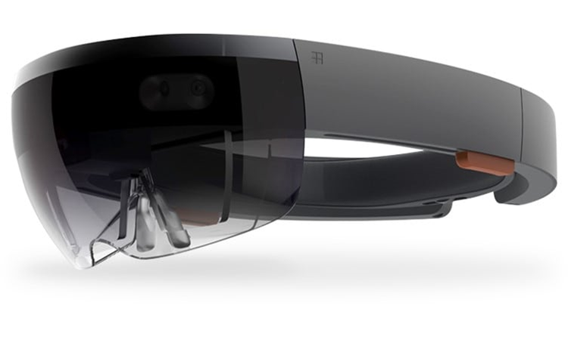

Fig 1: The Microsoft HoloLens

The general interaction occurs when we interact with an object. Inputs for interaction are following:

* Gaze: It allows us to simply look at an object like we target with our eyes.
* Gestures: It allows us to interact with the object at which we are Gazing (or aiming at through our eyes). There can be different forms of gestures, Hand Gestures Interactions, tap, place and others.

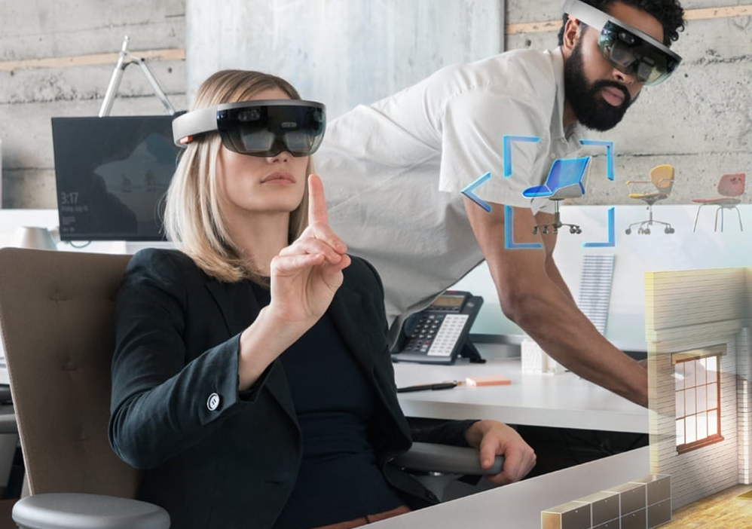

Fig 2: Tap Gesture

* Voice: The interaction with an object occurs when we are gazing at it and speaking voice commands.

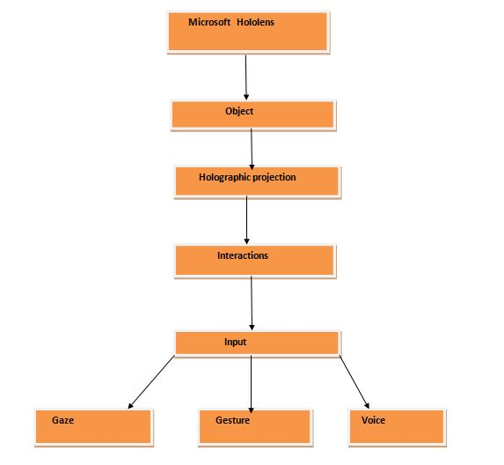

Fig 3: Interaction of virtual object and User Inputs

* 1. **MIXED REALITY**

Mixed Reality augments the real world with virtual objects as if they are really placed within the real environment. The virtual objects lock their positions according to their real world counterparts so as to produce a seamless view

Mixed reality is a term coined by Microsoft for Augmented Reality. It actually means combining both Augmented and Virtual Reality together to help users to interact with the virtual objects they have created using real world objects.

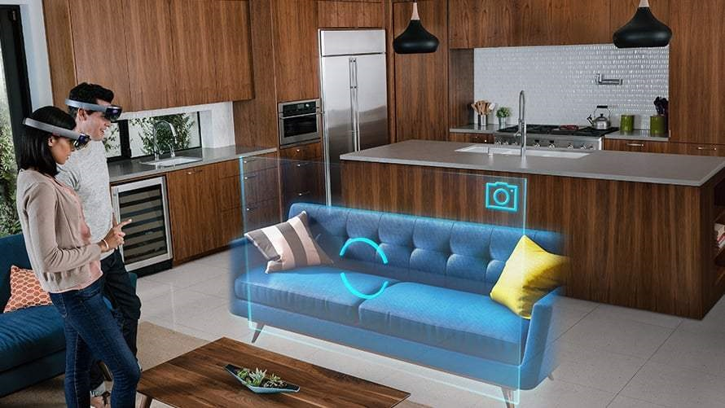

Fig 4: Mixed Reality Example

1. **PROFILE OF PROBLEM**

Interior HX is meant to be one of the most flexible, elegant, customizable, simple and easy application to design interior. The most important feature of Interior HX is a better user experience.

Creating an application for Microsoft HoloLens to enable the end-users to imagine their home and office furniture settings and buy their required items accordingly. The application let users to use their hands and voice as gestures and position the furniture as per their requirement having a live feed from the HoloLens of how the room will look after buying the actual furniture.

This gives a better and easier way of interior designing to the user and to buy furniture of their desire. From a new house to fully furnished house you can redesign your house anytime you want with objects with many varieties. It’s not limited its leads to infinite creativity and chance to explore.

HoloLens changes the way we see the world around us. It turned screen now into reality as real object. The objects blend with the real world object and act as they are just like real one.

1. **EXISTING SYSTEM**
   1. **INTRODUCTION**

Presently, there are many applications that let you click the pictures and position different furniture in different areas. Otherwise, one can buy the furniture, get it in place and if he/she doesn’t like the furniture, they can get it replaced. Right now, it’s a very hectic task because furniture are more often very heavy. The better solution is to get pictures and get it reviewed, still it won’t give the live feel and picture might tend to be incorrect.

* 1. **EXISTING SOFTWARE**

Presently, for home decoration and office decoration, there are many applications that one can use. Some of them are:

* + - 1. **VIEW IN MY ROOM 3D**

Take the guesswork out of online furniture shopping with this new feature on the Houzz app, which lets you try out products in your home before you buy it. Search from over 30000 items in the Houzz Shop, select ‘view in my room 3D,’ and a 3D version of the product will pop up in a photo of your space! Now you won't have to regret splurging on a statement piece that doesn't look quite right in person.

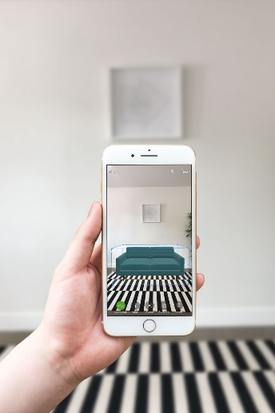

Fig 5: My 3D Room

* + 1. **COLOR CAPTURE**

This color matching app from Benjamin Moore allows you to take a picture of anything that inspires you and it will match the color to one of their 3,500 paint options. It’s practically shazam for paint! You can share your colors with friends via Facebook and Twitter to get a second opinion, or via e-mail to coordinate with your interior designer.

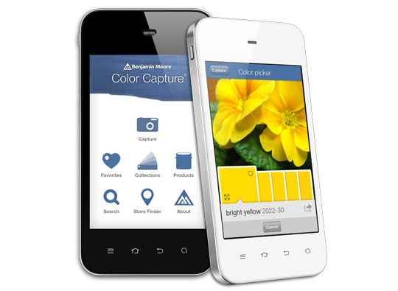

Fig 6: Color Capture

* + 1. **IHANDY CARPENTER**

The incredibly useful app, appropriately called iHandy, brings five essential decorating tools to the palm of your hand — like that bubble level bar you can never find. We like to use it for smaller projects, like hanging a new picture frame.

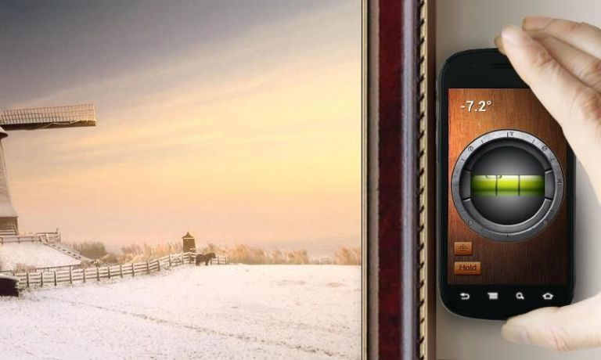

Fig 7: IHandy Carpenter

* + 1. **COLOR911**

Color911 has hundreds of color palettes, chosen by color consultant Amy Wax, but you can create custom palettes, too. Not sure which throw pillows works best with your new greige settee? You can also upload a photo of an item or room and the app will identify complementary colors.

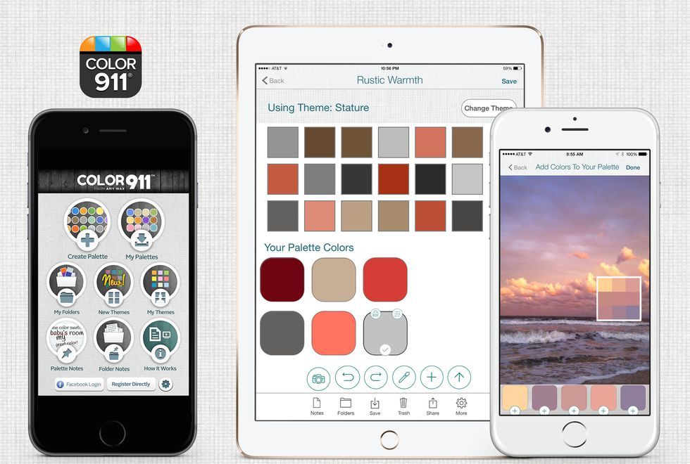

Fig 8: Color911

* + 1. **PHOTO MEAUSRES**

When shopping for furniture you could A) jot down all of your room measurements into your phone's notepad and then try to visualize what goes where when you get to the store. Or, B) download Photo Measures. The app lets you draw all of the dimensions of walls and flooring, directly onto a picture of the room.

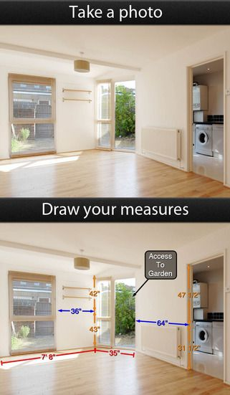

Fig 9: Photo Measure

* + 1. **MARK ON CALL**

Drawing up a floor plan might sound complicated, but Mark on Call makes it a breeze. Arrange and rearrange pieces in the app using custom measurements and pictures of your furniture and fabrics. If you don't like the flow, starting over is a snap.

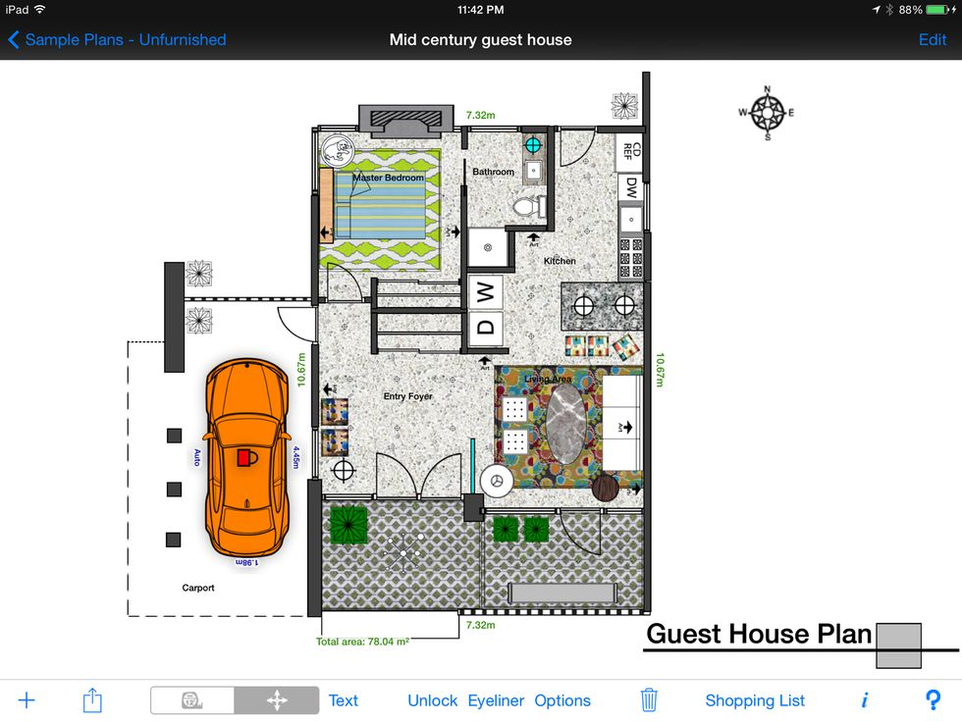

Fig 10: Mark on Call

* + 1. **TRY ON WALL**

If you're uncertain what exactly that gallery wall will look like, Try On Wall is here to help. Take a snap of your proposed backdrop and then place images on it virtually. You can even shop for pieces within the app.

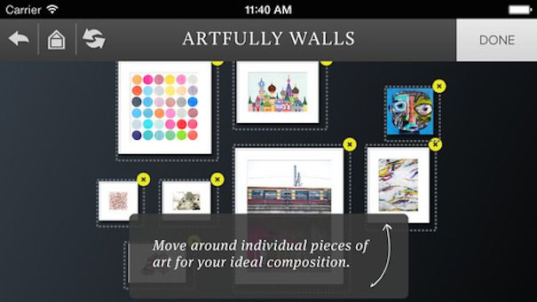

Fig 11: Try on Wall

* + 1. **OTHER SOFTWARES**

There are many other software out there for android and iOS operating systems. But as of now, interior designing application for Microsoft HoloLens is not in production or use. Therefore, to ease the process of home decoration, we have developed an application for HoloLens.

* 1. **WHAT’S NEW IN THE SYSTEM TO BE DEVELOPED**

The application ‘Interior HX’ is solely based on Microsoft HoloLens platform. Microsoft HoloLens uses the concept of Mixed Reality and enables the user to interact with the objects they have placed as per their requirement. Interaction can be done by voice or gesture commands. Hand gesture includes air tap, bloom gesture. For scaling, rotating, dragging or deleting an object we have a transformation menu and whenever an object is selected a blue boundary appears on it depicting that particular object is selected. Not only using such system can ease the workload on the end-users, it provides a great area of improvement of already positioned objects.

The users can use the HoloLens to scan the room and position the furniture without letting it collide with the real world objects. This is called Spatial Mapping. Spatial mapping provides a detailed representation of real-world surfaces in the environment around the HoloLens, allowing developers to create a convincing mixed reality experience. By merging the real world with the virtual world, an application can make holograms seem real. Applications can also more naturally align with user expectations by providing familiar real-world behaviors and interactions. The application is developed in Unity environment.

1. **PROBLEM ANALYSIS**
   1. **PRODUCT DEFINITION**

Interior HX is an application that uses mixed reality for home and office interior decoration. There are pre-defined virtual objects that can be interacted with using hand gestures and voice commands. The application is built in unity environment. The application requires a HoloLens as a platform to run on.

* 1. **FEASIBILITY ANALYSIS**
     1. **TECHNICAL FEASIBILITY**

The project will be developed using unity. It requires:

* Windows system with unity environment set up with a fast SSD and processor and RAM of more than 16GB.
* Latest Visual studio available on Microsoft website and kept on the same machine.
* Knowledge about C# and development of unity’s objects.

All the technical requirements can be easily fulfilled and all toolkits that are required and open sourced and can easily be pulled from GitHub. Development doesn’t require a big team but just a group of 5 developers so that the work can be divided and completed faster.

* + 1. **LEGAL FEASIBILITY**

All the toolkits used are open source and available for development. The unity and visual studio environment used are enterprise edition of both. No software or packages used for development is pulled from unknown sources.

The toolkits are pulled from HoloLens’ official GitHub repository, windows operating system is used with the unity development environment set up and both of these can be purchased from official pages as both the OS and the development environment are enterprise edition.

* 1. **PROJECT PLAN**
* Go through already available classes and application file to get knowledge of how the communication between unity and the HoloLens is established.
* Also getting familiar with the architecture of the mixed reality.
* Gain knowledge about how mixed reality works and how unity is used for virtual objects development.
* After this building a simple layout and making a successful connection with the HoloLens and getting the button manager and event triggers.
* Checking if the gesture reading could be received.
* Building scripts for the different functionalities like the voice commands and different gestures supported by HoloLens.
* Check the working of each gesture separately.
* Making a cluster of all controls into one screen space and check if each cluster works perfectly together.
* After a successful build of the UI, making algorithms to use the event handling and analyze the gestures to show useful information.
* Finally testing the built application and check for its accuracy and bugs.

1. **SOFTWARE REQUIREMENT ANALYSIS**

This section will contain all functional and quality requirements of the system. It will give a detailed description of the system and all its features.

**5.1 EXTERNAL INTERFACE REQUIREMENTS**

**5.1.1 USER INTERFACE**

The user will be presented with a head-mounted device and the OS is based on Windows 10. Every object can be viewed as 3d model from any side. Interior HX is a simple and easy platform or application with the help of which you can design the interior.

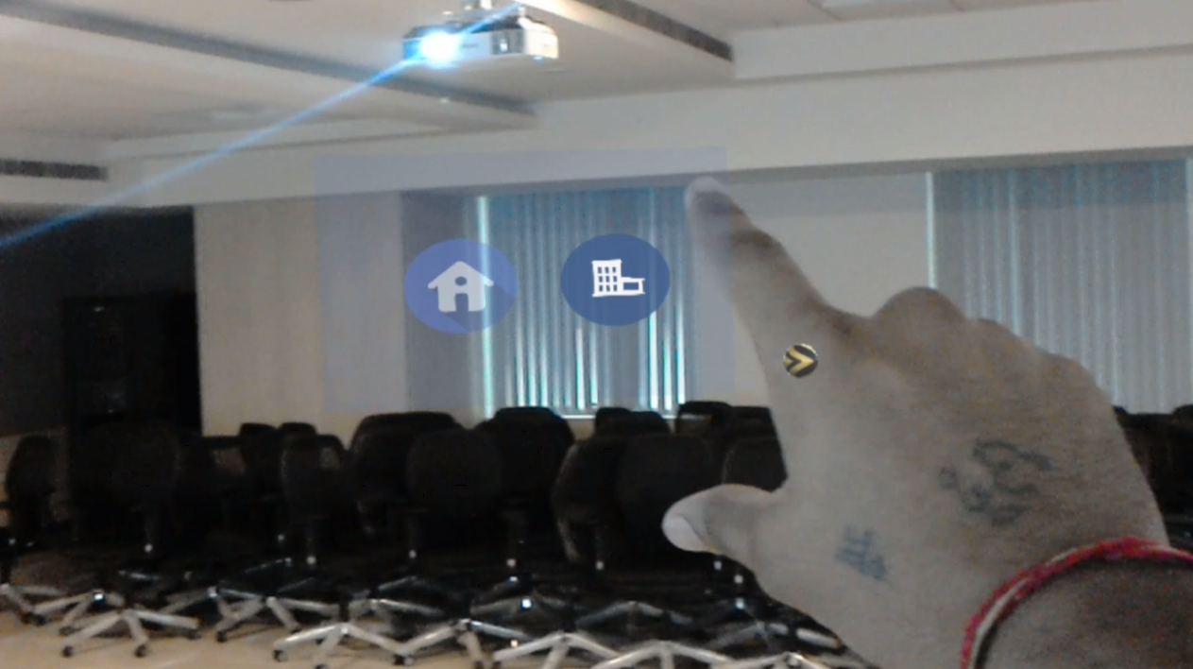

Figure 13: Interior-HX home screen

There are two icons on the home screen home and office. The home icon will take you the interior designing of home module. And the office icon will take you to the interior designing of office module. These are two buttons that will take you the particular module.

1. **Home Module** - In home module there are 8 icons. The icons are bed, sofa, TV, chair, fridge, table and back button. The back button will take you back to the main menu and there is one customize button that will take you the default templates for bedroom and the living-room.

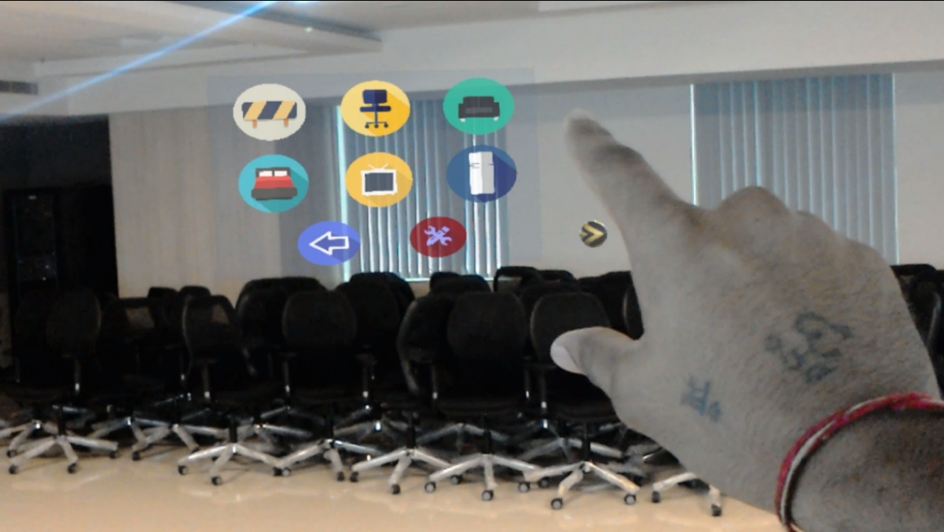

Figure 12: Home Menu

1. **Office Module** - In home module there are 7 icons. The icons are desk, cupboard, table, chair, back button and customize icon. The back button will take you back to the main menu there is one customize button that will take you the default templates for conference room and the cubicles.

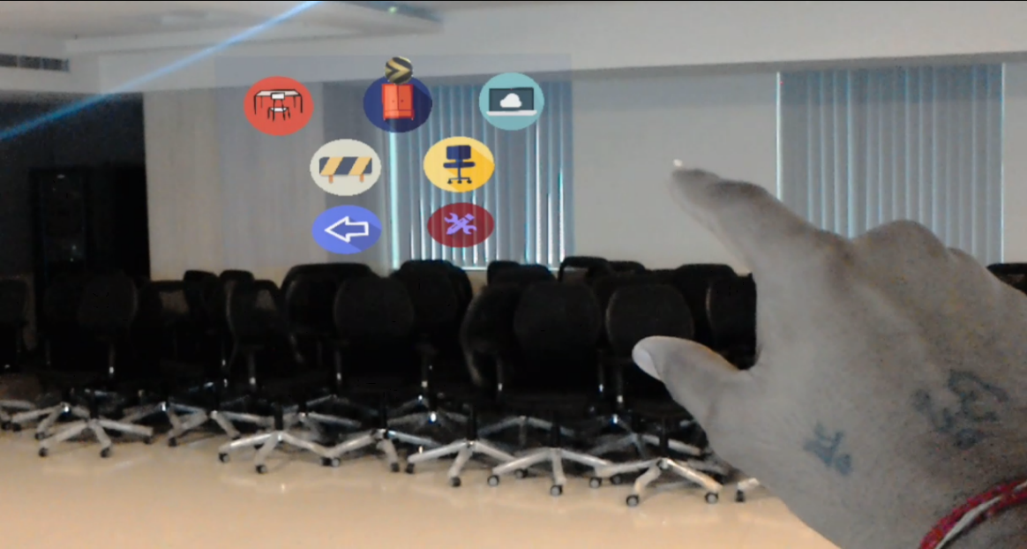

Figure 14: Office Menu

* + 1. **HARDWARE REQUIREMENTS**

This app is created on windows 10 based system which is running in the HoloLens, the sensors speakers, microphones, all that is required is present in the HoloLens.

* + 1. **SOFTWARE REQUIREMENTS**

This Application requires windows 10 as operating system with full configuration.

* 1. **FUCTIONAL REQUIREMENTS**
     1. **FUNCTIONAL REQUIREMENT 1**

**ID: FR1**

TITLE: UI

DESC: This Application requires the menus to navigate through the different option available in the Application like there are multiple objects so these objects should be categorized according to perfect suit.

DEP: None

* + 1. **FUNCTIONAL REQUIREMENT 2**

**ID: FR2**

TITLE: Multiple Objects Selection

DESC: The application have the functionality to select multiple instances of the same object and can select multiple different objects by just clicking on the button. Just click is required to select the object and get the object in the real world.

DEP: FR1

* + 1. **FUNCTIONAL REQUIREMENT 3**

**ID: FR3**

TITLE: Drag and Drop

DESC: After selecting the object you can customize this object and you can place it anywhere just by clicking on the drag and drop icon in the transform menu and with help of gestures. So only simple gestures are required to shift the object anywhere in the room or any place.

DEP: FR1, FR2

* + 1. **FUNCTIONAL REQUIREMENT 4**

**ID: FR4**

TITLE: Scale

DESC: After selecting the object you can customize this object and you can scale according to your need just by clicking on the scale icon in the transform menu and with help of gestures. So only simple gestures are required to scale the object.  
 DEP: FR1, FR2

* + 1. **FUNCTIONAL REQUIREMENT 5**

**ID: FR5**

TITLE: Remove

DESC: After selecting the object you can customize this object and you can remove the object according to your need just by clicking on the remove icon in the transform menu and with help of gestures.

DEP: FR1

* + 1. **FUNCTIONAL REQUIREMENT 6**

**ID: FR6**

TITLE: Rotate

DESC: After selecting the object you can customize this object and you can rotate according to your need just by clicking on the rotate icon in the transform menu and with help of gestures. So only simple gestures are required to rotate the object either to the left or to the right or 180 degree.

DEP: FR1

* + 1. **FUNCTIONAL REQUIREMENT 7**

**ID: FR7**

TITLE: Customizability

DESC: There is one custom icon which have default templates. These template have objects which are already set according to the room type of office and home. These templates are customizable according to the user need. You can remove the particular object and can add other object and can perform transformation on those object with the help of transform menu.

DEP: FR1, FR2, FR3, FR4

* + 1. **FUNCTIONAL REQUIREMENT 8**

**ID: FR8**

TITLE: Back button

DESC: There is back button in every panel or menu. So that you can navigate through the different panels.

DEP: FR1

* + 1. **FUNCTIONAL REQUIREMENT 9**

**ID: FR9**

TITLE: Transform Menu

DESC: The transform menu have all the four options like scale, rotate, drag and drop and the remove button on it. So you can transform the object by selecting particular transformation on the object from the transform menu.

DEP: FR1

* + 1. **FUNCTIONAL REQUIREMENT 10**

**ID: FR10**

TITLE: Box Collider

DESC: When the user will air tap or select the object. Just to show that the object is select we have used bounded box for that.

DEP: FR1

* + 1. **FUNCTIONAL REQUIREMENT 11**

**ID: FR11**

TITLE: Spatial Mapping

DESC: Spatial mapping is done when the application starts and that will map all the surroundings or real object as you will move your head.

DEP: None

* 1. **PERFORMANCE**

All the sensor reading keeps on changing the app should be capable of handling huge amount of data and also update its UI in real time. With doing so it should also be able to have quick response to touch events and function smoothly. Holographic applications need to balance visual complexity, presentation frame rate, rendering latency, input latency, power consumption for thermals, and battery life to achieve an optimal immersive experience. For user comfort, it is important to achieve consistent and high frame rates with minimal latency.

Applications should target 60 frames per second (fps) with 1 frame latency. The HoloLens display pipeline is able to upscale the application frame rate to match the display’s native frame rate by making small corrections to the presented frames based on very high frequency tracking information. This is critical to achieving stable holograms that behave like real world objects in the user’s holographic environment. Once the application achieves its target display rate, it is important to monitor power consumption and to ensure that the application operates within the designed thermal and power envelope of HoloLens.

Both frame rate and power consumption can be observed in the HoloLens Device Management System Performance view.

Essential Performance Targets

* Frame Rate: 60 fps
* Power Consumption: 1-minute average in orange and green area. See System Performance Tool information.
* Memory: < 900 MB Total Commit

1. **DESIGN**
   1. **SYSTEM DESIGN**

Development of the application is easy but we need to understand the flow how things work with Microsoft HoloLens. Microsoft HoloLens is the first self-contained, holographic computer, enabling you to engage with your digital content and interact with holograms in the world around you. The specialized components—like multiple sensors, advanced optics, and a custom holographic processing unit—enable us to go beyond the screen.

Mixed Reality with HoloLens: Mixed reality brings people, places, and objects from your physical and digital worlds together. This blended environment becomes your canvas, where you can create and enjoy a wide range of experiences.

With Mixed Reality and HoloLens we can provide better experience and your own customized world with less effort and time.

* + 1. **INTRODUCTION**

For designing an Interior we have two common ways. First, we can move from one place to another and check if it looks good or not. Problem here is it consumes time and for moving giant objects like sofa and beds it takes two or more people. The second way is by designing an interior design on a piece of paper and then visualizing it. But with Microsoft HoloLens we thought of creating something new and unique.

An application which can move huge objects on your fingertips and now you don’t need to imagine anymore it all there in front to you. You can scale, rotate and drag easily with much more effort. The advance feature of this application even makes buying furniture easy. You can see the object place it where ever you like it placing. Size it according to your own place and space.

* + 1. **ARCHITECTURE**

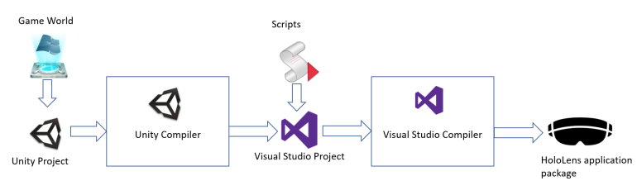

Figure 15: Workflow of application deployment

1. Development is done in Unity while scripting is done in C#
2. After compiling we get a file with .sln extension
3. Project is compiled with Visual Studio Compiler.
4. Now the project is ready for deploying in HoloLens.
   * 1. **INTERIOR DESIGN HX APP**

This application have a transformation menu with four different options that are Scale with which you can scale in or scale out your object and fit it in your own space. The next option is Rotate which allows user to rotate the object. And Drag option helps you to move the object from one place to another. The last option is Delete with this you can remove the object. When you select an object it has a blue boundary around it which shows this particular object is selected. And after selecting you can any transformation option.

The Menu contains two modules i.e. a home and another office. This application have predefined template for both the categories. With the help of template the user don’t need to start from zero. They can do the necessary changes in that predefined templates.

* 1. **PSEUDO CODE**

The application is supposed to work in exactly this order to work properly:

Creating new project

1. Start Unity.
2. Select New Project.
3. Name the project Interior Designing.
4. Make sure the project is set to 3D.
5. Click Create Project.

### Import project assets

1. Right click the **Assets** folder in the **Project** panel.
2. Click on **Import Package > Custom Package**.
3. Navigate to the project files you downloaded and click on **.unitypackage**.
4. Click **Open**.
5. After the package loads, click on the **Import** button.

### Setup the scene

1. In the Hierarchy, delete the **Main Camera**.
2. In the imported folder, open the **Input** folder, then open the **Prefabs** folder.
3. Drag and drop the prefab from the **Prefabs** folder into the **Hierarchy**.
4. Right-click the **Directional Light** in the Hierarchy and select **Delete**.
5. In the **Holograms** folder, drag and drop the following assets into the root of the **Hierarchy**:

### Save the project

1. Save the new scene: **File > Save Scene As**.
2. Click **New Folder** and name the folder **Scenes**.
3. Name the file and save it in the **Scenes** folder.

### Unity settings for HoloLens

1. Go to Edit > Project Settings > Player.
2. In the Inspector Panel for Player Settings, select the Windows Store icon.
3. Expand the XR Settings group.
4. In the Rendering section, check the Virtual Reality Supported checkbox to add a new Virtual Reality SDKs list.
5. Verify that Windows Mixed Reality appears in the list. If not, select the + button at the bottom of the list and choose Windows Holographic.

Next, we need to set our scripting backend to .NET.

1. Go to Edit > Project Settings > Player in the Inspector Panel for Player Settings, select the Windows Store icon.
2. In the Other Settings Configuration section, make sure that Scripting Backend is set to .NET

Finally, we'll update our quality settings to achieve a fast performance on HoloLens.

1. Go to Edit > Project Settings > Quality.

**Export the project from Unity to Visual Studio**

1. In Unity select File > Build Settings.
2. Select Windows Store in the Platform list and click Switch Platform.
3. Set SDK to Universal 10 and Build Type to D3D.
4. Check Unity C# Projects.
5. Click Add Open Scenes to add the scene.
6. Click Player Settings....
7. In the Inspector Panel select the Windows Store logo. Then select Publishing Settings.
8. In the Capabilities section, select the Microphone and Spatial Perception capabilities.
9. Back in the Build Settings window, click Build.
10. Create a New Folder named "App".
11. Single click the App Folder.
12. Press Select Folder.
13. When Unity is done, a File Explorer window will appear.
14. Open the App folder.
15. Open the Origami Visual Studio Solution.
16. Using the top toolbar in Visual Studio, change the target from Debug to Release and from ARM to X86.
17. Click on the arrow next to the Device button, and select HoloLens Emulator.
18. Click Debug -> Start without debugging or press Ctrl + F5.
19. **TESTING**
    1. **FUNCTIONAL TESTING**

Testing all the functionality of application with Microsoft HoloLens.

* + 1. **TESTING EACH FUNCTION WITH HOLOLENS**

1. Testing the application startup in HoloLens.
2. Testing the spatial mapping in living rooms, office, and conference hall.
3. Testing the main menu interface in HoloLens when application started.
4. Testing main menu interface with hand gesture and selecting the option home from main menu.
5. Testing each home panel object from home menu interface with hand gesture.
6. Placing the multiple home menu objects in empty room.
7. Testing the rotation, scaling, removing functionality of objects in room with hand gesture.
8. Testing the office menu interface with placing objects in office space environment.
9. Testing collision between the multiple objects in space.
10. Testing gaze pointing on objects with each interface of application.
11. Testing the back button and selection of home and office objects with different option of same kinds of objects.

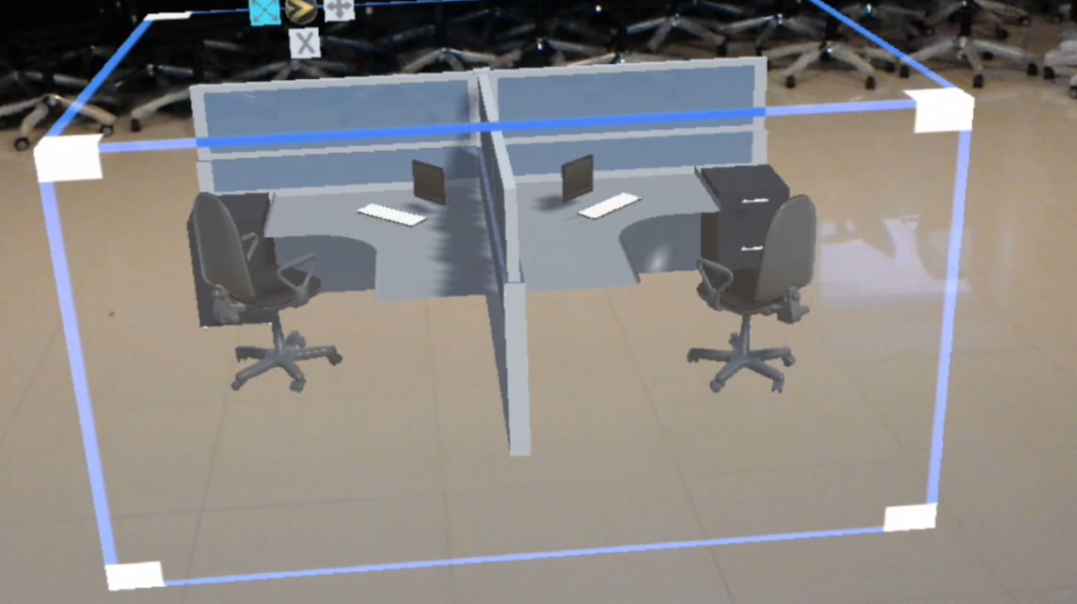

Figure 16: Testing object collision in HoloLens

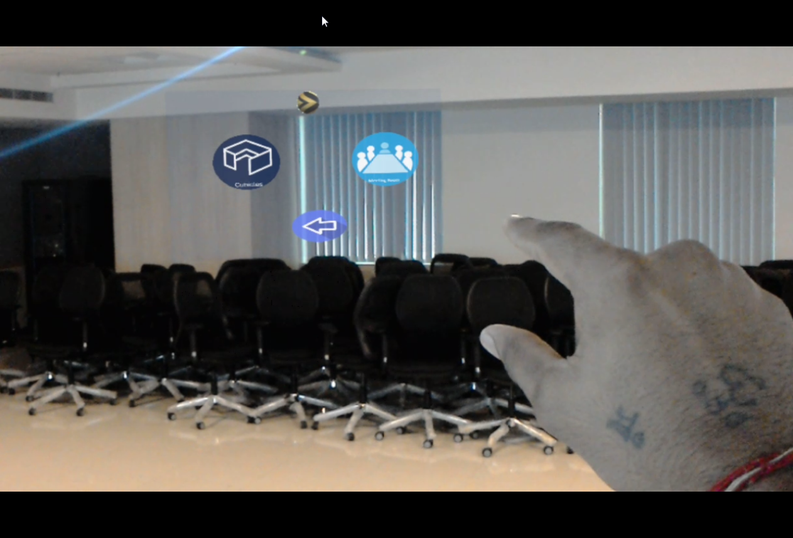

Figure 17: Testing customization menu for office layout

* 1. **STRUCTURAL TESTING**

Testing the structure of application simply open the application in HoloLens and check for time lag or any bug or crash when startup screen of application is open check the main menu interface is open in front of user and when user is moving the menu is on the same place or not. Check the selection of the any option in the main menu panel will open the next panel of application. Check the back button opening the previous menu. Check the gesture and gaze working for each panel of application working or any lag while selecting the options. Check the multiple option panel working as the requirement. Check the transform menu open when selecting any object.

System should be able to function normally and all functions should work properly.

* 1. **LEVELS OF TESTING**
     1. **TESTING MANUALLY**

All the user interface of application is tested in windows 10 system with unity application the design of menus, objects transformation and the on mouse click event on objects.

* + 1. **TESTING USING HOLOLENS EMULATOR**

The application is build and installed in HoloLens emulator and check all user interface functionality of application in HoloLens emulator while checking in emulator the gesture input is replace by the mouse input. Check all the transform menu functionality working in emulator. Spatial mapping functionality is not worked properly in emulator.

* + 1. **TESTING USING MICROSFT HOLOLENS**

After being certain that the Application runs properly and all the bugs were removed it is finally installed on a Microsoft HoloLens and tested there. The application tested in empty rooms and office all objects of home tested in empty and filled room and the office objects tested in office space.

1. **PROJECT LEGACY**
   1. **CURRENT STATUS OF PROJECT AND REMAINING AREAS OF CONCERN**

Currently all the functional requirements are fulfilled except we have not created the buying module entirely. Presently, we can add object which we want to buy into the database but we don’t have further processing for that. Another add on which I remaining is we need to use Artificial Intelligence so that when we choose an object from the menu then we should be able to get some recommended object with that selected object.

Another function as to be added in the next phase is we can create a full website for selling this object and the object selected by the user while using application can be directly added to his/her account using email id and password.

* 1. **TECHNICAL AND MANAGERIAL LESSONS LEARNT**

Working in this project was a challenge as Microsoft HoloLens was totally new device to work. And initially it was really difficult to deploy our project. I faced many issues while deploying, some were technical error and some HoloLens issues with the charging and its ability to heat up.

Overcoming all this took some time and then deploying on it was way much easier. Unity Documentation helped me at every stage of this project and helped me understood everything.

It was because of my Mentor and my team who helped me at every step that I was able to grab the knowledge as quick as possible. Now I know the how to work on HoloLens and let my creativity to change the world I see.

I can now develop application that not only can make Interior Designing easier but can make anything easier and better experiencing. I have learnt to create my own new world where dragging and dropping giant objects on my fingertips.

1. **SYSTEM SNAPS**



Figure 18 Main Menu Screenshot

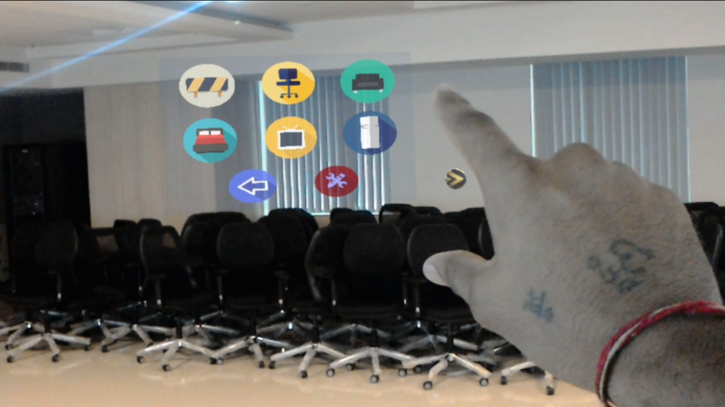

Figure 19: Home menu screenshot

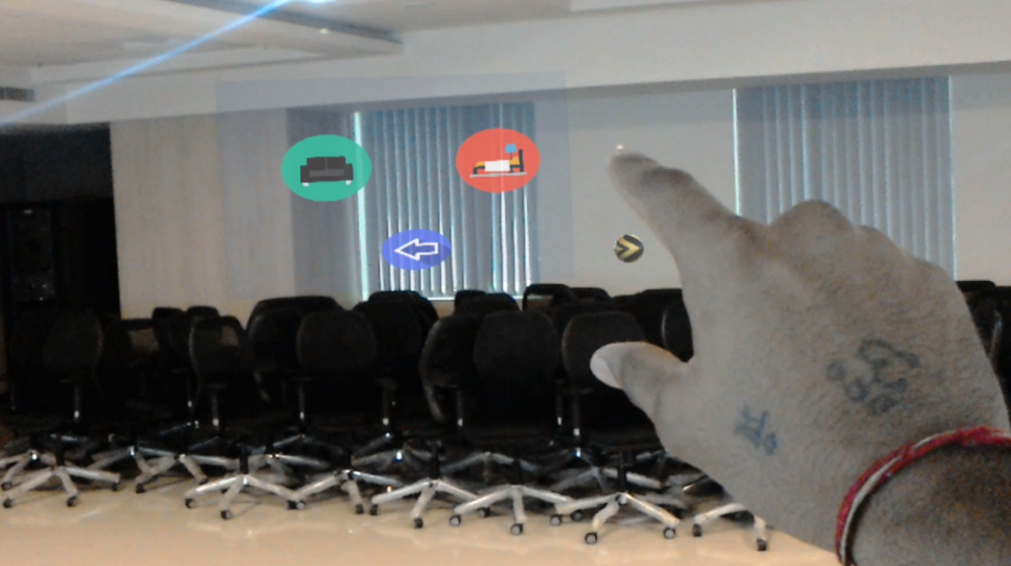

Figure 20: Home customize menu with bedroom and living room template

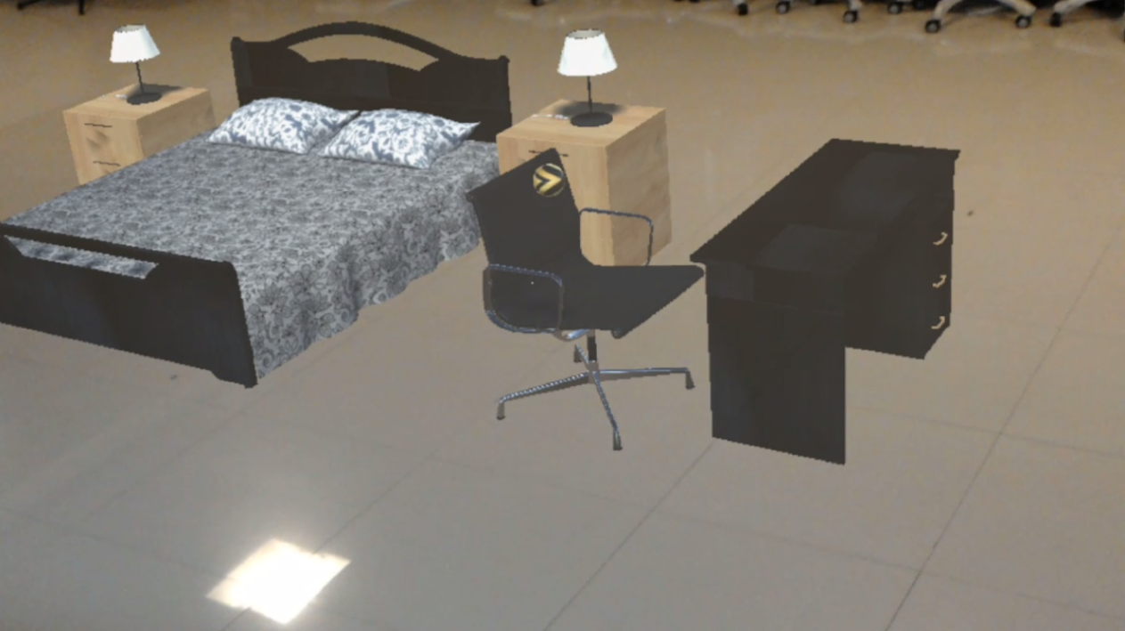

Figure 21: Bed room template screenshot

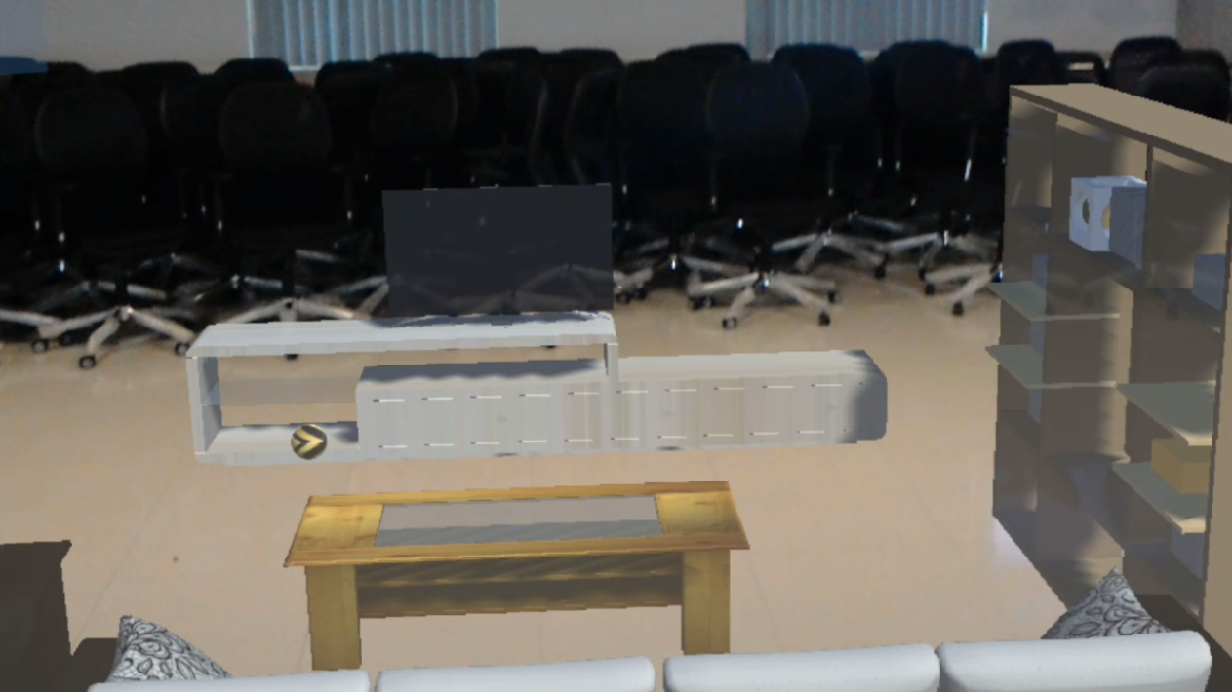

Figure 22: Living room template

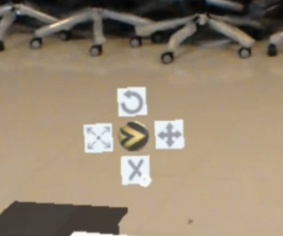

Figure 23: Transformation menu

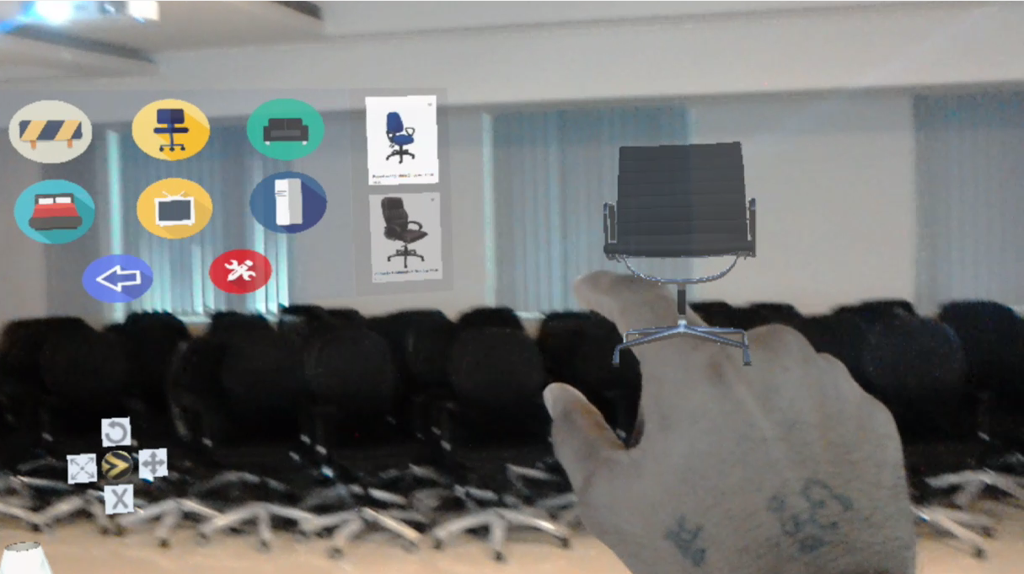

Figure 24: Multiple option for particular object

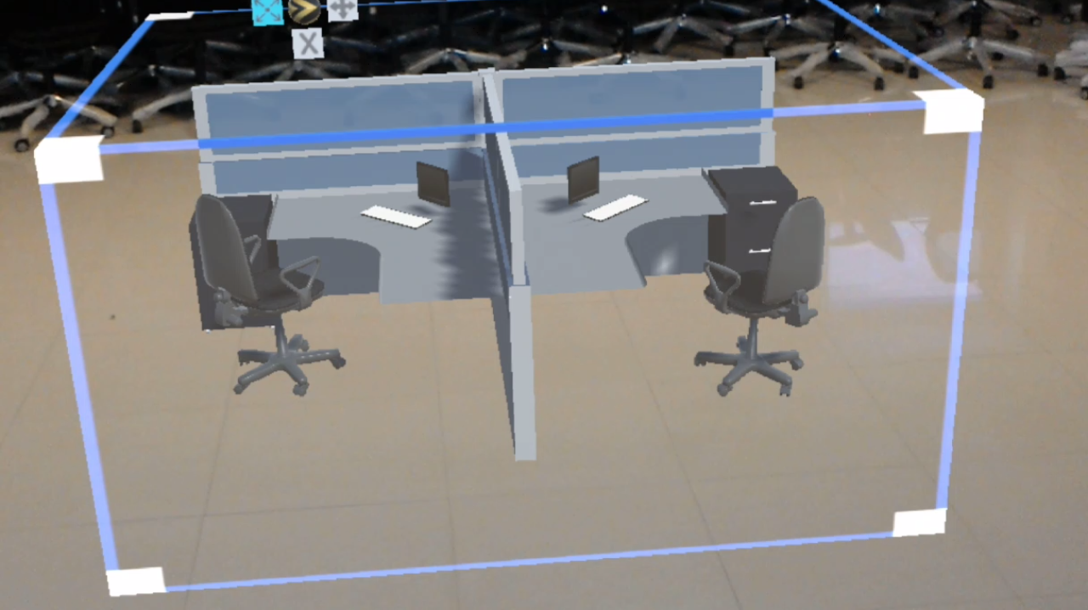

Figure 25: Cubical Template

1. **BIBLIOGRAPHY**
2. Introduction to HoloLens Application development [Online] available at: <https://www.sitepoint.com/getting-started-with-microsoft-hololens-developement/>
3. HoloLens Application development [Online] available at: https://microsoft.com/en-us/store/p/holoplanner/9nblggh4spf1#
4. HoloLens and Mixed Reality [Online] available at: <https://hololens.reality.new/collection/hololens-dev/>
5. Interior Designing using Microsoft HoloLens [Online Video] available at : <https://www.youtube.com/watch?v=lCRH50qyVd4>
6. Interior Design using HoloLens showcase [Online Video] available at: <https://www.youtube.com/watch?v=ajKw_-3IVQM>
7. Holo-toolkit for application development [Online] available at: <https://github.com/Microsoft/MixedRealityToolkit-Unity>